***Emergency Response Guide***

 

*Initial Release: 3/7/2019*

# Tab 1………… Initial Notification

# Tab 2………… Missing/Overdue Aircraft

# Tab 3………… Non HTCA Asset

# Tab 4………… Emergency Response Notification

# Tab 5………… Incident/Accident Determination

# Tab 6………… Incident Reporting

# Tab 7………… Accident Reporting

# Tab 8………… Approved Responses

# Tab 9………… Recall List

# Tab 10……….Witness Statement Guidelines

# Tab 11……….Internal Incident Investigation Guide

# Tab 12……….Phone/Action Log

# Tab 1

This tab is used to determine if an HTCA asset has been involved in an event. Use this tab to take down information from the witness calling with regard to the event.

**Begin the Call Tree at this point by Calling the Safety Officer and Dispatch referring to Tab 9.**

Log all calls and actions in Tab 12.

**If an event is witnessed by YOU and immediate response is deemed necessary, respond to the site for assistance with the Mishap Response Kit. Ensure that a radio is carried with you. Call the Safety Officer, Dispatch, or any available employee and have them start the Emergency Response Guide. Complete the Immediate Response Checklist below.**

Immediate Response Checklist

* Locate the Mishap Response Kit and bring it to the scene of the event. Ensure a charged handheld radio is available and bring it to the scene.
* Call 911 only if:
* Involved individuals or nearby persons are injured or require immediate medical attention.
* The aircraft is on fire or has caused a fire on nearby property.
* Event has occurred in a public area where spectators may hamper rescue and/or investigation efforts.
* If fire is present at the site, utilize the extinguisher as needed.
* If environmental hazards are present, utilize personal protective equipment located in the Mishap Response Kit to minimize exposure to potentially harmful materials.
* Remove personnel from the aircraft if there is danger of fire or hazardous materials.
* Provide first aid.
* Secure the site.
* Communicate with the Safety Officer, Dispatch, or whoever was tasked with initiating the Emergency Response Guide.
* Use non emergency numbers if law enforcement or fire response is needed for further support.
* Take photos of the site for use in investigations.

### 

### 

### 

### 

### 

### 

### Initial Report Worksheet

DO NOT give out information over the phone. This is especially important with regards to the crew members personal information. If you are the witness, proceed to Tab 4.

Call 911 only if:

* Involved individuals or nearby persons are injured or require immediate medical attention.
* The aircraft is on fire or has caused a fire on nearby property.
* Event has occurred in a public area where spectators may hamper rescue and/or investigation efforts.
* Date:________ Local Time:_______ Your Name:____________________
* Source Name: _______________________

Source Phone Number: _______________

* Description of Event: (If able, record your description using a voice recorder on your phone or take a video speaking of the event.)
* Time of Event:_________________
* Location of Event: (L/L)_______________
* Have Search and Rescue assets been notified?_______________
* Have Fire/Medical been notified?___________________________
* Has the NTSB Been notified?______________________________
* Others Notified:
* Condition of personnel involved:
* Describe damage and condition of the aircraft:
* Is there any damage to private property? Describe:
* Weather at the scene of the event:
* Any video or photographs of the event:
* Any additional information: Other witnesses:

Ask the caller to assist in securing the site if needed until law enforcement arrives to do so. Caution the caller as to the hazards associated with an accident site. Ask the caller to remain near a phone.

### Event Verification

This checklist is used to confirm that an event has occurred and to determine if an HTCA aircraft has been involved in an accident or incident.

* Make a confirmation call to the person initially calling in the event.
* Begin the communications tree located in Tab 9 of the Emergency Response Guide.
* Determine if the aircraft involved is an HTCA asset by checking the flight schedule and inquiring with dispatch if applicable.
* If the aircraft is determined to **not** be an HTCA asset, turn to **Tab 3** to determine next steps and how to assist.
* If the aircraft **is** determined to be an HTCA asset, turn to **Tab 4** regardless of if HTCA personnel are involved or not.
* Complete the call tree in Tab 9. Log all calls and actions in Tab 12.

# 

# 

# 

# 

# 

# Tab 2

This tab is used when an aircraft is reported missing, suspected missing, or overdue.

# 

# 

# 

# 

# 

# 

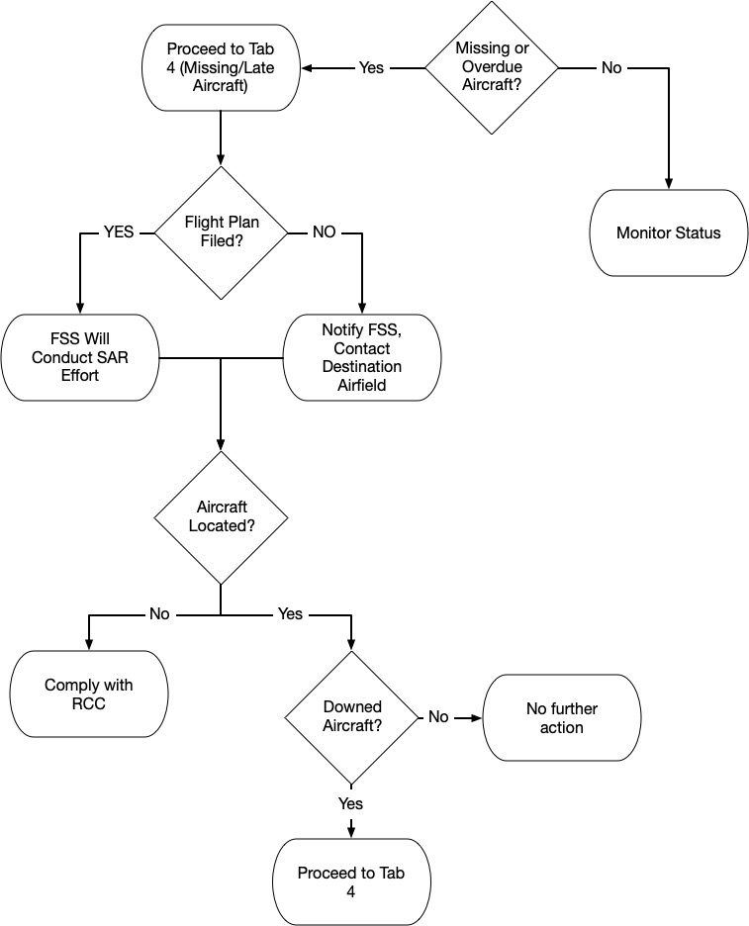

# Tab 3

This tab is used when the aircraft involved in the event is **NOT** an HTCA asset.

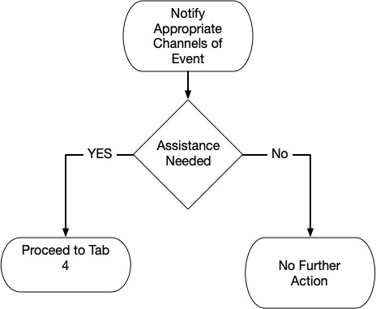

### Non HTCA Asset Involved Event

Determine if assistance is needed. If no assistance is needed, log all actions taken in Tab 12. If assistance is needed, go to Tab 4.

# Tab 4

This tab is used to initiate accident notification that is external to HTCA. The first step is to ensure that search and rescue, medical, and local law enforcement are notified if required. The initial notification worksheet will assist in determining this.

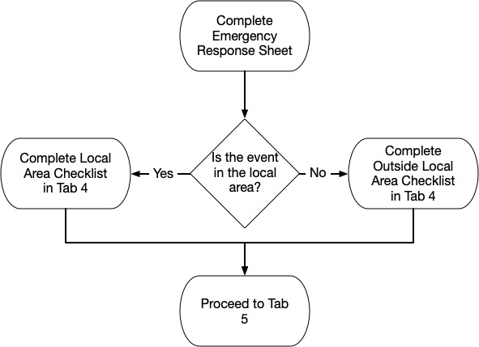

### 

### Emergency Response Notification

This checklist shall be used to initiate accident notification external to HTCA if needed. The first step is to ensure that search and rescue, medical, and local law enforcement are notified. The priority of actions for this tab are as follows:

* Protect people- Life saving operations take first priority.
* Protect property- Property should be protected from further damage.
* Preserve evidence- Treat the area as if it were a crime scene. Provide area security until the investigation team arrives.

**Missing/Late Aircraft**

* Determine if the missing aircraft filed and opened a flight plan prior to departure.
* Notify dispatch of the overdue aircraft **503-665-4896**.
* **If a flight plan was filed** the following actions will be completed automatically. (No FBO action is required unless queried by FSS or ARTCC.)
  + Search and Rescue should automatically be initiated. FSS will initiate SAR procedures in accordance with the National SAR plan for all VFR flights on filed flight plans. ARTCC will initiate SAR procedures for IFR flights.
  + FSS/ARTCC will send a QALQ to the destination tie in facility to query the flight plan specifics of the overdue aircraft. If the aircraft is located during this time, the tie in facility will close the flight plan and cancel the QALQ.
  + If the aircraft is not located from the QALQ or has not been located within 30 minutes after it has become overdue, the destination tie in facility will transmit an INREQ (Information Request) to the departure airport, en route FSS, and en route ARTCCs.

*-If an INREQ is received FSS will complete the following actions-*

* Seek information about the aircraft by checking facility records and all flight plan area airports along the proposed route of flight that could accommodate the aircraft. This action is expected to be completed within 1 hour of INREQ receipt.
* If the replies to the INREQ are negative or if the aircraft is not located within 1 hour after INREQ transmission, the destination station will transmit an ALNOT (Alert Notice) to the ROC (Regional Operations Center) and the RCC (Rescue Coordination Center). The search area will be 50 miles each side of the proposed route of flight from the last reported position to the destination.
* Communication searches will be completed with all of the airports within the search area. Local law enforcement will be called upon to search any airport that can not be contacted.
* Aircraft traversing the search area may be asked to assist in the search.
* If the ALNOT has come up negative, the RCC will take over the SAR mission.
* If FSS or ARTCC personnel contact the FBO due to an issued INREQ or ALNOT
  + Comply with requests in a timely manner.
  + When aircraft arrive at the FBO, remind them to close flight plans.
* **If no flight plan was filed**, communicate with other HTCA assets that may be airborne to see if they have heard communication from the overdue aircraft.
* Notify TacAero Dispatch **503 665-4896** and Safety Officer, **541 645-5235**.
* If the overdue aircraft is an instructional flight, determine a likely operating area based on the lesson to be completed.
* Direct other HTCA airborne assets to proceed to the determined operating area and attempt to communicate with the overdue aircraft on guard frequency.
* If the aircraft cannot be located within 30 minutes of its overdue time, initiate Search and Rescue procedures by contacting FSS.
* Provide the following information to the FSS.
  + Color of aircraft.
  + Time of last radio transmission if known.
  + Last position report if known.
  + Operating area if known.
  + Any actions taken to locate the aircraft.
  + Number of people on board.
  + Fuel status if known.
* Comply with FSS requests and instructions. Log all actions in Tab 12 of the Emergency Response Guide.
* If the aircraft is not located through the INREQ and ALNOT procedures, comply with any RCC requests during the search and rescue operation.
* If the aircraft is located, proceed to the Event Outside of Local Field checklist in this Tab.

**Event Outside of Local Field**

* Determine phone numbers for local law enforcement and fire/rescue.
* Utilize information received from the initial response report to determine emergency response involvement. Call 911 only if:
  + Involved individuals or nearby persons are injured or require immediate medical attention.
  + The aircraft is on fire or has caused a fire on nearby property.
  + Event has occurred in a public area where spectators may hamper rescue and/or investigation efforts.
* Call TacAero Safety Officer **541 645-5235**
* Call Airport Manager **541 386-5116**
* Utilize non-emergency numbers to keep local law enforcement, fire, and rescue personnel informed.
* Attempt to communicate with the PIC of the aircraft to determine the current status of the aircraft and area the aircraft is located.
* Determine the best way to access the aircraft and pilot.
* Ensure that the PIC has completed the PIC Accident/Incident Checklist.
* Continue to Tab 5 to determine the event classification.

**Local Event**

* Utilize information received from the initial response report or personal observation to determine emergency response involvement.
* Call TacAero Safety Officer **541 645-5235**
* Call Airport Manager **541 386-5116**
* Call Port of Hood River Communications Manager **541 386-6145**
* If the Immediate Response Checklist was not executed and the determination is made to directly respond to the site the following actions should be taken:
* Conduct risk management and implement mitigations. This is required in an effort to ensure rescuers or first responders do not become injured themselves. The following hazards may be present:
  + Biological hazards
  + Toxic substances
  + Pressure vessels
  + Mechanical hazards
  + Fire hazards
  + Environmental hazards
* Locate the mishap response kit and bring it to the scene of the event. Ensure a charged handheld radio is available and bring it to the scene.
* Utilize personal protective equipment located in the Mishap Response Kit to minimize exposure to potentially harmful materials.
* Call 911 only if:
  + Involved individuals or nearby persons are injured or require immediate medical attention.
  + The aircraft is on fire or has caused a fire on nearby property.
  + Event has occurred in a public area where spectators may hamper rescue and/or investigation efforts.
* Minimize disturbing the event scene. Only move material in an effort to remove personnel.
* Utilize non-emergency numbers to keep local law enforcement, fire, and rescue agencies informed of status.
  + Call local law enforcement if assistance is needed in keeping the site secure.
  + Call Fire Department if hazardous materials have spilled.
* If the PIC has not completed the PIC Accident/Incident Checklist, assist them in completing it.
* Continue to Tab 5 to determine the event classification.

# Tab 5

This tab is used to determine if the reported or observed event is considered an incident or an accident and should be reported at the Federal level.

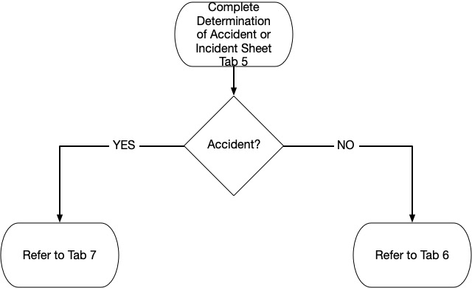

### Event Classification

* Ensure the Safety Officer is involved with the following checklist.

Classifying the reported/observed event as an accident or an incident is a critical step in the mishap response plan. Utilize the following checklist to determine if the event is classified as an accident or an incident.

* Did the event result in any fatalities?
* Did the event cause serious injuries?
  + Expected hospitalization >48 hours
  + Fractured of any bone other than fingers, toes, or nose
  + Severe hemorrhages or nerve damage
  + 2nd or 3rd degree burns (or any burn over 5% of the body surface)
* Did the event cause substantial damage to the airframe?
  + Failure which adversely affects structural strength, performance, or flight characteristics.

NOTE: Bent prop blades, damage to landing gear, wheels, tires, flaps, wingtips, and small puncture holes in fabric are NOT considered substantial damage.

* If the answer to any above question is YES, the event is classified as an accident and must be reported to the NTSB. Refer to Tab 6.
* The following events are classified as incidents but ARE required to be reported to the NTSB. Refer to Tab 6.
  + Flight control system malfunctions.
  + In flight fires.
  + Aircraft collision in flight.
  + Property damage >$25,000 for repair.
* If the event is not covered by any of the above check boxes, the event is considered an incident and does not require reporting to the NTSB. However, internal reporting to the HTCA Safety Officer IS required. Refer to Tab 5.

# Tab 6

This tab is used for internal reporting requirements for an aircraft incident.

**Incidents that are not reportable will be investigated internally by HTCA. Incidents are investigated as a means of hazard identification avoidance.**

### Aircraft Incident Reporting Checklist

Refer to the following Checklist when reporting aircraft incidents. Recall information is located in Tab 9. Update the chronological phone/action log in Tab 12 when calls are made.

* Notify the HTCA Safety Officer that an aircraft incident has occured. Provide information received during the initial notification. Ensure that the Safety Officer concurs with the initial event classification as an incident.
* Remove the Flight Schedule from any public platform.
* Notify HTCA Maintenance that there has been an aircraft incident involving an HTCA aircraft. Direct Maintenance to pull all logbooks on the involved aircraft.
* Notify Chief Pilot and Chief Instructor Pilot, if flight was an instructional event.
* Pull aircrew pilot logbooks and any training records if applicable.
* Notify the HTCA President and Vice President that there has been an aircraft incident involving an HTCA asset.
* Call Insurance Agent and inform of the incident. Determine what information is initially required for insurance claim purposes. Request to move the aircraft if the PIC has not done so already. Comply with Insurance Agent’s immediate requests.
* Do not relay incident specifics if questioned by the general public or the media. Refer them to the HTCA President. Tab 8 contains example responses to inquiries.
* Coordinate with FBO or Maintenance Department for movement of the aircraft to an appropriate area.
* Refer to Tabs 10 and 11 as needed when conducting an internal investigation into the incident.

# Tab 7

This tab is used for NTSB reporting requirements for an aircraft accident.

### Aircraft Accident (Reportable Incident) Reporting Checklist

Refer to the following Checklist when reporting aircraft incidents. Recall information is located in Tab 9. Update the chronological phone/action log in Tab 12 when calls are made.

* Notify the HTCA Safety Officer that an aircraft accident has occurred and their presence is requested. Give a brief description and ensure that the Safety Officer concurs with the event classification of an accident. (or reportable incident).
* Report the accident to the NTSB Response Operations Center. **844-373-9922 or 202-314-6290**
* Provide the following information to the NTSB:
  + Type, Nationality, and registration marks of the aircraft
  + Name of the owner and operator of the aircraft
  + Name of the PIC
  + Date and time of the accident
  + Last point of departure and point of intended landing
  + Position of aircraft referencing geological points
  + Number of persons on board, killed, or seriously injured
  + Nature of the accident, weather, and extent of damage
  + Description of any explosives
* Notify the HTCA President and Vice President that an aircraft accident has occurred and their presence is requested.
* Remove the Flight Schedule from any public platform.
* Notify HTCA Maintenance that there has been an aircraft incident involving an HTCA aircraft. Direct Maintenance to pull all logbooks on the involved aircraft.
* Notify Chief Pilot and Chief Instructor Pilot, if flight was an instructional event.
* Pull aircrew pilot logbooks and any training records if applicable.
* Call Insurance Agent and inform of the accident. Determine what information is initially required for insurance claim purposes. Comply with Insurance Agent’s immediate requests.
* Await instruction from the NTSB with how to proceed with the accident aircraft. Do not move or disturb the aircraft until told to do so by the NTSB.
* Do not relay incident specifics if questioned by the general public or the media. Refer them to the HTCA President. Tab 7 contains example responses to inquiries.
* Coordinate with FBO or Maintenance Department for movement of the aircraft to an appropriate area when cleared by the NTSB to do so.
* If directed to assist the NTSB with any investigation, comply with all requests.

# 

# Tab 8

This tab is used as a reference for responses to inquiries.

### Approved Telephone Responses

The following responses are approved to be given when an inquiry is made regarding an accident or incident. ‘If pressed for specifics, refer the individual to the HTCA President and the Port of Hood River Communications Manager.

* Call from non-employee, news, media, etc.”:

“I am unable to give out any information at this time and suggest that you contact the company President or Port of Hood River at (XXX)XXX-XXXX”

* Call from Next of Kin or other company employee:

“ We have knowledge of a possible aircraft incident or accident but are not certain it involves one of our aircraft. We need to keep the phone lines clear to gather information. Where are you now and what number can you be reached at?”

# 

# Tab 9

This tab is used to ensure that all required personnel are informed of the aircraft accident. Follow the list and make calls as required. If an individual cannot be reached, continue on to the end of the list. Once at the end, re-attempt uncompleted calls. DO NOT give accident information to anyone who is not on this list.

Recall List (4S2)

|  |  |  |  |
| --- | --- | --- | --- |
| **Personnel** | **Phone Number** | **Alternate** | **Called/Message** |
| Dispatch | 503 665-4896 |  |  |
| Safety Officer | 541 645-5235 |  |  |
| HTCA President | 541 399-2469 |  |  |
| HTCA VP | 701 610-6581 |  |  |
| Director of Maintenance | 509 406-3872 |  |  |
| 4S2 FBO Manager | 844 359-2827 |  |  |
| Director of Facilities | 541 288-6766 |  |  |
| Chief Pilot | 509 637-3368 |  |  |
| Chief Instructor Pilot | 509 947-8989 |  |  |
| Airport Manager* | 541 386-5116 |  |  |
| Port Communications* | 541 386-7263 |  |  |
| Hood River Sheriff* | 911 | 541 386-2711  (Non Emergency) |  |
| Hood River Police* | 911 | 541 386-2121  (Non Emergency) |  |
| Hood River Fire* | 911 | 541 386-3939  (Non Emergency) |  |
| Westside Fire* | 911 | 541 386-1550  (Non Emergency) |  |
| NTSB* | 844 373-9922 | 202 314-6290 |  |
| FSS* | 866 833-7631 |  |  |

* Call only for the applicable areas addressed in the Emergency Response Plan. Do not notify FSS or NTSB unless the mishap has been deemed reportable.

Recall List (KDLS)

|  |  |  |  |
| --- | --- | --- | --- |
| **Personnel** | **Phone Number** | **Alternate** | **Called/Message** |
| Dispatch | 503 665-4896 |  |  |
| Safety Officer | 541 645-5235 |  |  |
| HTCA President | 541 399-2469 |  |  |
| HTCA VP | 701 610-6581 |  |  |
| Director of Maintenance | 509 406-3872 |  |  |
| KDLS FBO Manager | 509 767-0005 |  |  |
| Director of Facilities | 541 288-6766 |  |  |
| Chief Pilot | 509 637-3368 |  |  |
| Chief Instructor Pilot | 509 947-8989 |  |  |
| Airport Manager* |  |  |  |
| Port Communications* |  |  |  |
| Sheriff* | 911 |  |  |
| Police* | 911 |  |  |
| Fire* | 911 |  |  |
| Fire* | 911 |  |  |
| NTSB* | 844 373-9922 | 202 314-6290 |  |
| FSS* | 866 833-7631 |  |  |

* Call only for the applicable areas addressed in the Emergency Response Plan. Do not notify FSS or NTSB unless the mishap has been deemed reportable.

# 

# Tab 10

This tab is used as a guide for obtaining witness statements.

### Obtaining Witness Statements

Witness statements may be considered to be of a privileged nature and shall not be disclosed without the witnesses approval or consent. When taking a witness statement, ensure that you explain to the witness that their testimony is not taken under oath and that it is obtained under the assurance that the testimony may be privileged if desired and will not be used in any legal or punitive action. In addition, the witness may be invited to express personal opinions or speculate as to the possible mishap causal factors. This should be explained to the witness prior to obtaining a statement in order that the witness will not withhold certain important evidence by invoking their constitutional rights

The immediate location of the witness is an important step in the conduct of a successful investigation. Many times the initial statements made by the witness will point directly to the immediate area in which the investigation should be concentrated and may save valuable time and energy in conducting the investigation.

Witnesses at the event site will have information as to the movement or configuration of the aircraft in question just prior to the accident or incident. Do not overlook the possibility of contacting witnesses in surrounding areas as they may also have valuable information.

Try to obtain statements from witnesses as soon as possible and preferably before witnesses are able to compare their views with others to prevent skewed reports. Always request recall information from the witness so clarifying information can be requested at a later time.

Statements from the flight crew should be taken as soon as possible depending on their condition. Obtain an interview with the PIC and other flight members with the concurrence of medical personnel if applicable.

When gathering witness statements observe the following:

* Allow the witness to relate their own story without interruption.
* Record the statement verbatim of possible.
* Use any models, if available, to assist the witness in describing the flight characteristics and flight path of the aircraft.

# Tab 11

This tab is used as a guide for internal investigations into an incident.

### Internal Incident Investigation Guide

The following information contains instructions to facilitate investigation immediately following an incident. The classification of an event as an incident does not mean that there is not potentially hazardous aircraft wreckage or debris that exists at the incident site. Caution should be exercised and risk management applied to mitigate potential hazards.

If applicable:

* Impact angle __________ Deg.
* Attitude at time of impact ____________________ Deg. (Nose up, Level,etc.)
* Point of initial impact________________________
* Type of wreckage distribution _________________
* Aircraft configuration________________________
* Type of terrain______________________________
* Condition of terrain__________________________
* Evidence of fire ____________________________
* Weather at the scene: Cieling________; Visibility_______; Type Weather_______; Temp_______; Dew Point_________; Wind_________
* Cursory Investigation:
* Interviews
  + PIC, Flight Crew
  + Maintenance Personnel
  + Tower if applicable
  + Other pilots who witnessed the incident
  + Any witness who has a statement
  + Medical personnel if applicable
* Photographs. Take multiple photographs to document the incident.
  + Scenes of cockpit covering all appropriate switches, handles, control units, and safety items.
  + General incident scene covering position of landing gear, flaps, and control surfaces.
  + Scenes of path along the runway or ground with emphasis on contact point and position of any scattered parts.
  + Any views of the aircraft showing obvious material failure.
  + Keep a detailed photo log.
* Once cleared by the insurance company to move the aircraft, coordinate with the Maintenance Department or FBO to complete the move.
* Review maintenance logs for the incident aircraft in detail.
* Review pilot and crewmember logbooks and training folders in detail.

# Tab 12

This tab is used to keep a chronological log of all actions taken in the event of an aircraft accident. This log is needed to ensure that all essential information connected with the event are recorded as they are received.

### Chronological Phone / Action Log

|  |  |  |
| --- | --- | --- |
| **Date/Time:** | **Event (Call, Message, Action, etc.):** | **By Whom:** |
|  |  |  |
|  |  |  |
|  |  |  |
|  |  |  |
|  |  |  |
|  |  |  |
|  |  |  |
|  |  |  |
|  |  |  |
|  |  |  |
|  |  |  |
|  |  |  |
|  |  |  |
|  |  |  |
|  |  |  |
|  |  |  |
|  |  |  |
|  |  |  |
|  |  |  |
|  |  |  |

|  |  |  |
| --- | --- | --- |
| **Date/Time:** | **Event (Call, Message, etc.):** | **By Whom:** |
|  |  |  |
|  |  |  |
|  |  |  |
|  |  |  |
|  |  |  |
|  |  |  |
|  |  |  |
|  |  |  |
|  |  |  |
|  |  |  |
|  |  |  |
|  |  |  |
|  |  |  |
|  |  |  |
|  |  |  |
|  |  |  |
|  |  |  |
|  |  |  |
|  |  |  |
|  |  |  |

|  |  |  |
| --- | --- | --- |
| **Date/Time:** | **Event (Call, Message, etc.):** | **By Whom:** |
|  |  |  |
|  |  |  |
|  |  |  |
|  |  |  |
|  |  |  |
|  |  |  |
|  |  |  |
|  |  |  |
|  |  |  |
|  |  |  |
|  |  |  |
|  |  |  |
|  |  |  |
|  |  |  |
|  |  |  |
|  |  |  |
|  |  |  |
|  |  |  |
|  |  |  |
|  |  |  |